Assignment 1.3

The History of DevOps
Deployment failure. After months of developers working on dozens of features and patches, months more of testing, and even more time spent fixing the unintended collisions from the team. The release deadline passed, and a fatal error was missed because the fixes for the collisions introduced a collision that prevented the program from connecting to the server. Unfortunately, this was not uncommon. Enter DevOps! Although the three main tenets of DevOps did not all come about at once. The Lean Movement helped reduce wasted time, the Agile Manifesto's principles for faster build times, and Continuous Delivery (CD) help software update continually, eliminating wasted time and bottlenecks in development. These three tenets together make up the DevOps philosophy, which helps push software and software updates quickly and with higher quality.
These tenets did not develop together, nor did they all come about in software. The Lean Movement originated with Toyota Production Systems in the 1930s. The Lean Movement focuses on eliminating waste during production and on delivering only what brings value to the customer. If it doesn’t bring value to the customer, it is a waste that needs to be removed. The principles of Lean are:
- Define value from the customer’s standpoint
- Map the value stream to identify every step from concept to delivery
- Create a flow so work moves without interruption
- Establish pull so work is only started where there is actual demand
- Seek perfection through continuous improvement.
When applied to software, Lean enables developers to spot inefficiencies in the delivery pipeline, such as slow manual handoffs, redundant approvals, context switching, and more. These are done using tools and processes such as value stream mapping, Kanban boards, WIP limits, and others. All these workers work together to reduce the lead time, or time at the start of the development process.
The most common Software Development Life Cycle was the Waterfall method. And even though this method is still in use today, it is largely considered wasteful and inefficient for large projects. At its simplest, Waterfall works by completing one part of a project before moving on to the next. The process is long and drawn out, and it relies heavily on documentation. It often produced results that were not in line with the customer's needs because it was very difficult to adapt to the client's changing needs. So, a group of seventeen developers got together at a ski resort in Utah and wrote the Agile Manifesto. The basic idea is to address planning issues and allow changes throughout the development life cycle. This is accomplished by incorporating these four values:
- People over process
- Working software over documentation
- Customer collaboration over contracts
- Responsiveness to change over rigid plans
What these did was help implement the Lean process more seamlessly into the planning and development phases. What it did not do was solve the issues that would happen at the end of the production cycle: deployment.
Lean helped eliminate waste at the front of the development cycle; Agile pushed it further, making planning and development more efficient. All that remained was to improve the deployment phase with Continuous Delivery. If Agile means requirements can change on the fly, why can’t the deployed software change on the fly? The answer at the time was that there was no fast and safe way to issue updates. If something was released that broke software, there wasn’t a way to hit the undo button. So, the CD/CI pipeline, managed with version control, came into play. Version control allowed developers to work from a centralized repository, and the CI/CD pipeline meant that when a developer committed their code, it could be sent to the deployment environment immediately, eliminating waste at the end of the cycle.
The term DevOps emerged from the convergence of these three principles. Patrick Debois, a Belgian consultant, was watching a live stream on Agile Systems when he was inspired to create the #DevOps. In October of 2009, the Debois organized the first DevOpsDays conference, giving the movement a formal name. DevOps enables companies to establish a software development pipeline that supports daily, sometimes hourly, commits and updates to the deployment environment.
DevOps is the combination of Lean thinking, Agile values, and the CD/CI practices. The waterfall of confusion created by over-documenting and under-communicating was not a technical problem but an organizational one. In 2025, nearly 80% of software development firms use a DevOps mentality (Octopus Deploy, 2025). That doesn’t happen because it’s a fad or because it’s what the big tech giants do (even though Amazon, Netflix, and Google all led the way on this from the start). This happens because it works.

This is a very helpful infographic I found that details the timeline of DevOps after its creation:
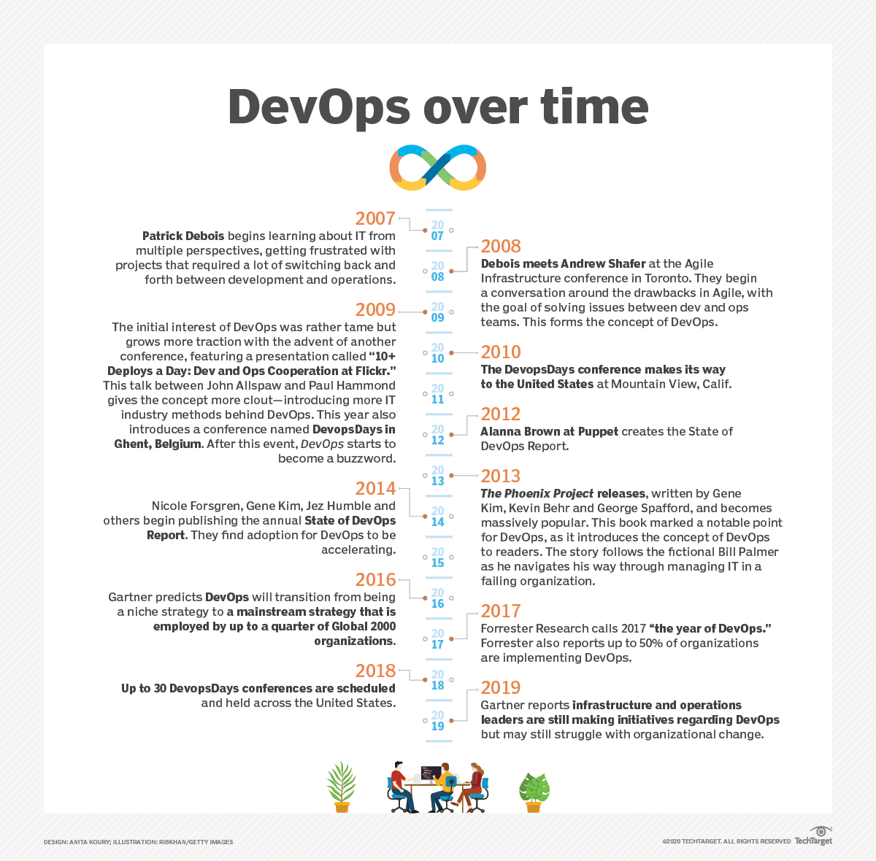
Figure 1. Timeline of DevOps milestones from 2007 to present. From "The history of DevOps: A visual timeline," by A. S. Gillis, 2020, TechTarget (https://www.techtarget.com/whatis/reference/The-history-of-DevOps-A-visual-timeline). Copyright 2020 by TechTarget.

References

Atlassian. (n.d.). 8 key continuous delivery principles. https://www.atlassian.com/continuous-delivery/principles
Atlassian. (n.d.). Agile manifesto for software development. https://www.atlassian.com/agile/manifesto
Atlassian. (n.d.). Lean vs. Agile. https://www.atlassian.com/agile/project-management/lean-vs-agile
Buchanan, I. (n.d.). History of DevOps. Atlassian. https://www.atlassian.com/devops/what-is-devops/history-of-devops
Gillis, A. S. (2020, July 31). The history of DevOps: A visual timeline [Infographic]. TechTarget. https://www.techtarget.com/whatis/reference/The-history-of-DevOps-A-visual-timeline
Kim, G., Humble, J., Debois, P., & Willis, J. (2016). The DevOps Handbook: How to create world-class agility, reliability, and security in technology organizations. IT Revolution Press.
Octopus Deploy. (2025). 48 DevOps statistics to know in 2025. Octopus Deploy. https://octopus.com/devops/metrics/devops-statistics/

